Anamêlés «Mariage»
Solution

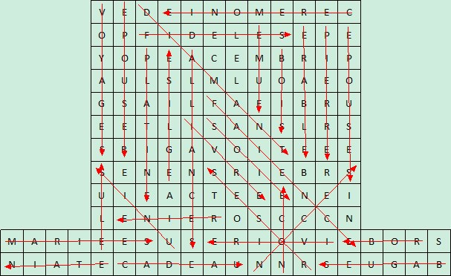

Solution => CÉLÉBRATIONS

